PhoneVS 1.2:
Installation and User’s Guide

Introduction
This document describes the installation and set-up and the main functionality of the PhoneVS application release 1.2. PhoneVS is an application for mobile phones with Java (J2ME with profile MIDP 2.0 and configuration CLDC 1.0). This application allows the display of live video images from a VS unit connected to the Internet.
The following section describes the Installation and Set-up procedure of PhoneVS. Section User’s Guidedescribes the main functions of the application. Finally, section Error Messages describes the meaning of the error messages given by the application in case of problems.

Installation and Set-Up
The application is prepared to run in mobile phones with Java (J2ME with profile MIDP 2.0 and configuration CLDC 1.0). The application has been tested in several Nokia and Motorola terminals (e.g. Nokia 6630, 6670, 6680, Motorola V220, Motorola V3). If you are using a different terminal complying with the J2ME specification mentioned above and you still experiment problems, please contact technical support.
To install the application you need the following elements:
- A PC with MS-Windows installed
- Your mobile phone supporting Java
- A cable to connect the mobile device to the PC
- An application given by the mobile phone manufacturer to install applications in your mobile phone.
- The installable application phoneVS1-2beta.zip
To install PhoneVS in the mobile phone you must follow the steps indicated here after.
- Uncompress the archive phone phoneVS1-2beta.zip in a temporal directory, e.g. C:\tmp.
- Connect the mobile phone to the PC using the cable provided by the manufacturer (usually a USB cable).
- Run the application installation of the mobile phone.
- Specify to the installation application to install the archive file PhoneVS.jar (e.g. C:\tmp\PhoneVS.jar in the example above)
- Complete the installation process from the screen of the mobile phone.
Beyond this point, the application PhoneVS will be installed in the mobile phone.

Special Instructions for NOKIA
Some mobile phones require from the user to configure additional parameters to allow the PhonesVS application to access the Internet. For example, Nokia 6000 phones have an application called “Application Manager” to allow the user to modify the settings of the applications. Note that this application is dependant on the manufacturer and the particular model you are using. The following procedure is described for Nokia 6000 phones.
- Go to the folder “Tools” of the mobile phone and start “Application Manager.” You should get a list of applications installed in your mobile phone.
- Select the PhoneVS application and display the “Options” menu.
- Select “Adjust” and select “Network Access.”
- Select the option “Ask the first time”. This will configure the application to ask for permission to access the network with the first image. Subsequent attempts to read images from remote VS units will not ask for permission any more.

User’s Guide
When PhoneVS is installed in your mobile phone, the list of accessible VS devices has four empty slots. The screen of the mobile phone presents the following aspect:
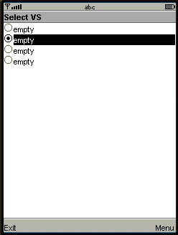
Figure 1: “Select VS” screen of the application
Before accessing aVS unit you must introduce the access data in the mobile phone. The VS list of the application allows for the data of up to four remote VS units to be stored in the phone. To enter the data of your unit you must display the Menu and select the “Edit VS” item as follows.
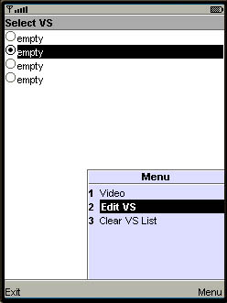
Figure 2: Selection menu of “Select VS” screen
Selecting “Edit VS” brings the corresponding screen to the display as follows.
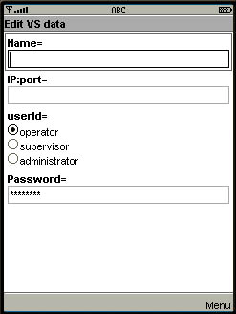
Figure 3: “Edit VS data” screen of the application
The “Edit VS data” screen presents the following fields:
- Name= This is the symbolic name you want to give to your VS unit. It will be the name appearing in the “Select VS” screen for that particular unit. For example, you can use: DVR demo as name for the unit.
- IP:port= This is the IP address and port of the VS unit. A valid IP address and port is:
dvr.vtdemo.net:82
(if the port is the standard port 80 it can be omitted).
- userid= This is the user identification you want to use to access the VS unit. You can select one of the three user levels of the VS units: operator, supervisor or administrator. Note however that regardless of the level used the application will only display live video.
- Password= This is the password of the selected user in the corresponding VS unit. If the password is the standard password of a VS unit you do not have to type it. Otherwise, you will have to introduce the password paying attention to use of right case (capital or lower letters).
After completing the VS unit data, you must write them to permanent store by selecting the “OK” option of the menu as follows.
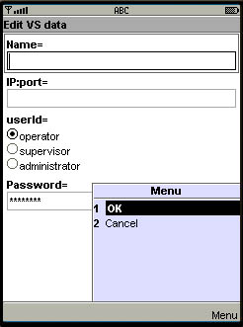
Figure 4: Menu of “Edit VS data” screen
If you want to discard the data select “Cancel” in the menu.
After introducing the previous data, the “Select VS” screen will present the following aspect.
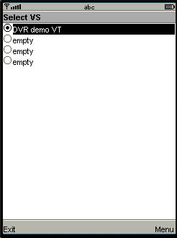
Figure 5: “Select VS” screen with one VS unit
You can repeat the previous process up to four times. To delete the data of a VS unit it is sufficient to delete all the characters of the “IP:port” field. To delete all the information of the four VS units stored in the phone you can select the option “Clear VS List” in the menu.
Once a valid VS unit is entered in the list, you can select it to obtain live video from the unit. For selecting live video you must go to the menu and select the option “Video” as follows.
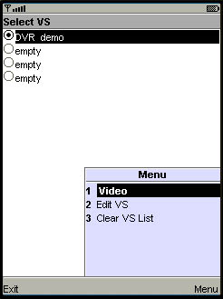
Figure 6: “Video” selection from “DVR demo” unit
After selecting “Video” the phone will ask for permission to connect to the network with a message similar to this one.
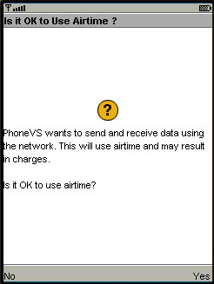
Figure 7: Requesting permission to connect to the network for the first time
To allow the PhoneVS application to proceed you should answer “Yes.” This will display the first image of the selected VS in the screen.

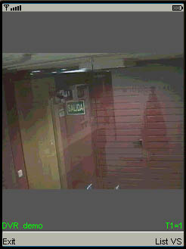
Figure 8: “Live Video” screen with first image received
The lower part of the screen shows a text linein green indicating the name of the remote VS unit to which you have connected. It also shows the number of the camera displayed and the number of images read since the application started. Before the number of the camera, a letter indicates the display mode as follows.
- “T”: indicating tour mode. This mode makes an automatic tour around all the cameras of the remote VS unit. This is the default mode after selection of a new VS unit.
- “C”: indicating camera mode. All the images belong to the selected camera.
To select a camera one must click on the camera number in the phone keyboard. Thus, if you want to select camera 5, you should click on the key with the number “5” in the phone. To select cameras from 10 to 16, click first the “*” key followed by the two figures of the camera number desired. Thus to select camera 12, you must click “*” “1” “2” in sequence.
To select tour mode again, click “0”.

Error Messages
The previous section describes the normal working mode of the application. If some communication problem with the current VS arises, a message will appear in the center of the screen. The most common messages displayed are as follows.
- “Error: (cannot connect)” This messages indicates that the selected VS unit cannot be accessed and thus a communication error has taken place.
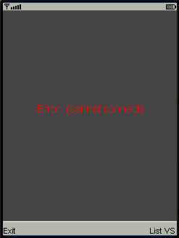
Figure 9: Error message indicating that the VS unit is not accessible
- “Error: (invalid password)” This messages indicates that the password specified for the selected VS unit is wrong.
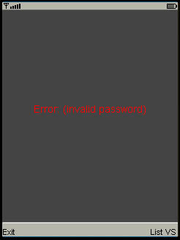
Figure 10: Error message indicating wrong password for the selected VS unit
- “Internal Error” This messages indicates an error of unknown origin. It usually indicates an incompatibility between the phone and the application and some problem with the configuration of the Internet in the phone terminal. If this error is present, contact the manufacturer of the application.
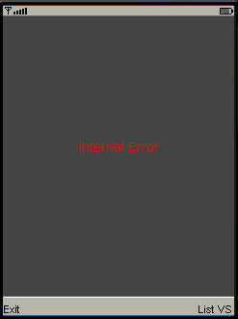
Figure 11: Internal Error

