Solution 1 TCP/IP WAN with Local work station, Remote WorkStations and remote control panels using 4164ETH Interfaces
ROME

MILAN
HOST PC

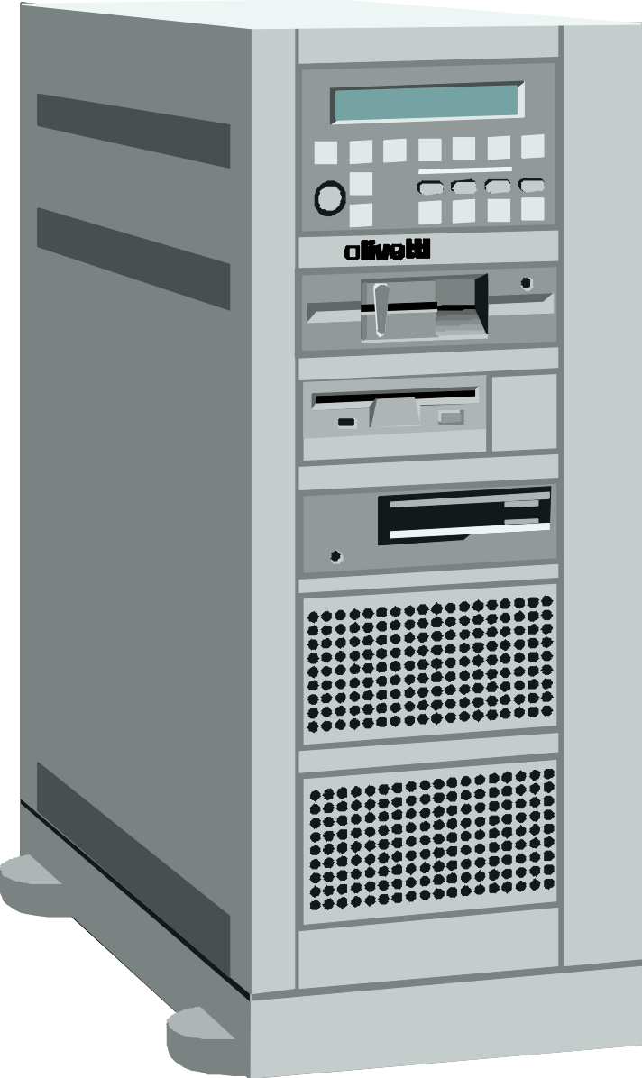

Ethernet Lan
HUB
Ethernet Lan
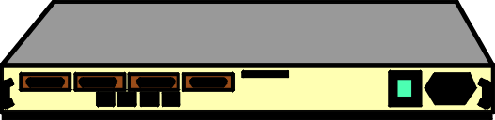
Router
Relay Board
Work Station 1
Router

ISDN Line
ISDN Line

TCP/IP
FLORENCE
VENICE

ISDN Line

ISDN Line
Ethernet Lan
Ethernet Lan

Router
Router

Vista Control Panel and 4164ETH Interfaces

Solution 2 TCP/IP WAN Multi HOST with Local WorkStations, Remote WorkStations and remote control panels using 4164ETH Interfaces

As solution 1
HOST PC
MILAN

Ethernet Lan
HUB
VENICE
Relay Board
Ethernet Lan
Work Station 1
Router
ISDN Line
ISDN Line

Router

TCP/IP
FLORENCE

ROME
As solution 1

HOST PC
Ethernet Lan
ISDN Line
Ethernet Lan
HUB
Router
Relay Board
Work Station x
Router
ISDN Line

Vista Control Panel and 4164ETH Interfaces

